Chester County Community Foundation Convenes Nonprofit Leaders Across Chester County for Community Conversations

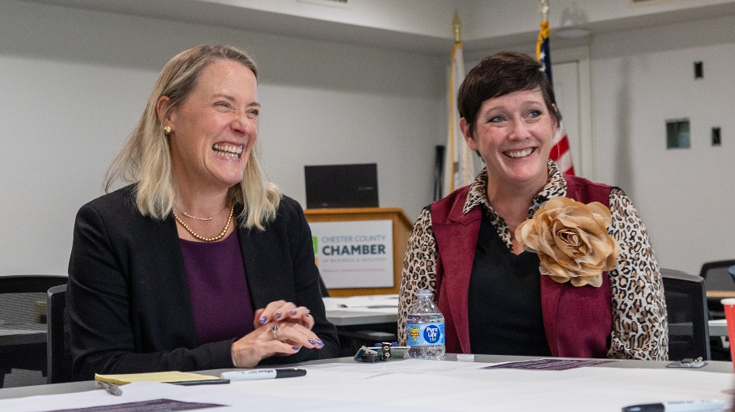

(West Chester, PA – October 9, 2026): The Chester County Community Foundation recently convened nonprofit leaders together from across Chester County for a series of Community Conversations designed to listen, learn, and better understand how the Community Foundation can support the organizations and people serving the county.

Led by President & CEO Kate Wickersham, CFRE, and facilitated by Chief Impact Officer, Chaya Scott, CAP, six Community Conversations were held with past grantees in Coatesville, Phoenixville, Kennett Square, Exton, Malvern and Oxford, creating opportunities for the nonprofit leaders to share their experiences and perspectives.

The fall conversations centered around three key areas: grantmaking, training, and community leadership. Participants completed an online survey to share their past experiences and shared their ideas for the future of philanthropy in Chester County.

“The best way for us to understand how the Community Foundation can have the greatest impact is to hear directly from the people serving our communities every day,” said Wickersham. “What we learned from our nonprofit partners will help us think intentionally about how we move forward together: from how we approach grantmaking, to the trainings we provide, to the role we can play in bringing people together.”

The small group format gave nonprofit leaders an opportunity to connect with one another, exchange ideas and discuss both the challenges they are encountering and the opportunities they see within their communities.

The Nonprofit Community Conversations are part of Wickersham’s broader listening efforts during her first year as President & CEO. Additional conversations are planned with previous Community Foundation program participants. Professional advisors, donors, volunteers, and other community members can also share their perspectives through online surveys and future engagement opportunities.

“Our work touches many different people and organizations, and each brings an important perspective to the table,” Wickerham said. “Ultimately, these conversations are about making sure the Community Foundation continues to evolve alongside the community we serve.”

To learn more about Community Conversations with Kate, visit chescocf.org/commconvokate.

Photo top: Meghan Sayer, Executive Director, Paoli Hospital Foundation (L) and Kate Wickersham, CFRE, President & CEO, Chester County Community Foundation (R)

Photo bottom: Attendees in Coatesville, PA on September 1.

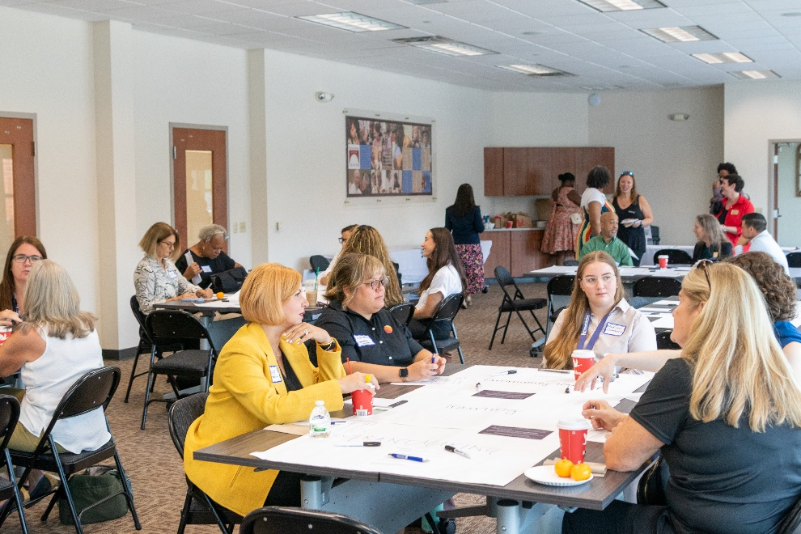

***

About the Chester County Community Foundation

Headquartered in West Chester’s Lincoln Building, the Chester County Community Foundation connects people who care with causes that matter so their legacy philanthropy makes a difference now and forever. The Community Foundation is entrusted with nearly $145 million in community assets, and annually awards $8+ million in grants and scholarships. www.chescocf.org
###

